Logo%20Main%20200

**Boston University**

**Electrical & Computer Engineering**

**EC464 Capstone Senior Design Project**

User's Manual



Submitted to

Andy Whitman and Anthony Burnes

Fathom Fishing

abyrne19@bu.edu

andy@fathom.fishing

by Team 34 PUCKFish

Team Members

Victoria Thomas vmthomas@bu.edu

Alex Necakov alexrn@bu.edu

Peter Ha peterha@bu.edu

Will Aracri waracri@bu.edu

Ammar Hussain hussaina@bu.edu

Submitted: 4/18/2022

#### PUCKfish

#### Table of Contents

PUCKfish 2

Table of Contents 2

**Executive Summary** **4**

**Introduction** **1**

**System Overview and Installation** **2**

Overview block diagram 2

Physical description 3

Installation, setup, and support 3

**PUCKFish Operating Modes** **5**

Operating Mode 1: Normal Operation 5

Operating Mode 2: Abnormal Operations 5

Safety Issues 5

**Technical Background** **6**

4.1 Introduction: Lobster Ecology and Environment 6

4.2 Sensors: Modus Operandi and Selection 7

4.2.1 Temperature and Depth 7

4.2.2 Ambient Light 7

4.2.3 Dissolved Oxygen 8

4.2.4 Salinity 8

4.2.5 Current Speed and Direction 8

4.3: Enclosure and Protection Against the Elements 9

4.3.1: Waterproofing 9

4.3.2: Pressure Resistance 9

4.3.3: Floatation 9

4.4: Data Transmission and Charging 10

4.4.1: Data Transmission 10

4.4.2: Charging 10

**Relevant Engineering Standards** **11**

**Cost Breakdown** **12**

**Appendices** **14**

Appendix A – Team Information 14

# 

**Team History**

Alex, Victoria, Peter and Will met during freshman year through the Rocket Propulsion Group. They have worked together on various projects for the team including liquid rocket engines, test stands, and other assorted infrastructure. After a short break due to the pandemic, the team found themselves back in Boston for senior year, ready to team up again to take on a multi-disciplinary project.

Ammar and Peter went to high school together in Boston. Seeing the requirement we had for an extra hand on the electrical engineering team, Ammar fit right in and got to work as one of our two electrical engineers.

# The team is excited to be working together with BU alumni and Fathom Fishing. The team hopes to produce a piece of engineering that supports local industry and protects the right whale population off the coast of its home in New England.

# Executive Summary

The lobster fishing industry has largely remained unchanged since its emergence in the mid 1800s. The primary strategy for lobster fishing has also remained unchanged since the mid 1800s, where fishermen place traps upon habitual routes with no promise of a good catch yield This strategy leads fishermen to place extraneous traps throughout the ocean in areas unlikely to house lobsters. These extraneous traps have a significant environmental impact on other marine life such as the endangered North American Right Whale. The whales become caught in the lines of lobster traps and then perish, making “line entanglement” the leading cause of unnatural death among this population. Due to these environmental concerns, fishermen are limited by law in the number of traps they can place.

PUCKFish solves this by providing low-cost, rugged instrumentation to fisheries. This device puts the tools for data acquisition and analysis in the hands of trappers providing information to inform data-backed decisions about where to place lobster traps and optimizing fishing hauls. We will be producing three PUCKFish data collection devices each of which records six key metrics relevant to lobster activity on the seafloor. PUCKFish will be the first business-grade, all-in-one data collection and analysis suite specifically for lobster fishermen. Its low cost and ability to collect metrics most critical to locating and tracking lobsters will revolutionize the lobster fishing industry.

# Introduction

PUCKFish is an instrumentation package designed to provide the most relevant data to lobster trappers. This data will significantly reduce the number of traps needed to provide the same catch, and thus the trash and emissions produced through fishing activities.

Thus, PUCKFish must be extremely resistant to water, corrosion, pressure, cold, and, potentially, oceanic wildlife. These issues are all addressed concurrently by wholly immersing the electronics in a non-conductive, eco-friendly epoxy resin. The resin completely isolates the internal electronics from the outside environment while still allowing us to mold the resin as necessary to allow the appropriate sensors external access. PUCKFish can survive up to 11,000 psi, over 20 times what we expect on the ocean floor, for over two weeks.

Sensors with external access were specially sourced to be appropriate for the extremely harsh oceanic conditions, with additional sealing precautions taken around their base. These additional sealing measures prevent any possible ingress, for example, at the interface between the pressure sensor and the PCB. As we cannot put a wired charging port on PUCKFish, it instead uses inductive wireless charging.

Because PUCKFish will be left at depth for extended periods, it must be efficient with its energy usage to maximize the operation time available on a single charge. With a 500 mAh battery, and an extremely low polling rate, PUCKFish will be able to last for up to two weeks underwater. And should it lose power, all data is backed up to a 512MB SD card locally. With a packet size of merely 256 bytes, saturating the SD card is essentially impossible given the rigid schedules of the lobster trapping industry.

We are proud to present PUCKFish. Further technical information and operational instructions are available below.

# System Overview and Installation

PUCKFish is a translucent, spherical, underwater data collection device with one flat face for standing and one exposed eye-bolt for mounting. The outer shell of the PUCKFish is made of translucent epoxy. The interior (or core) of the device consists of a printed circuit board mounted on a white plastic skeleton, with a microcontroller and several sensor boards attached to it. These sensor boards capture water current speed/direction, temperature, ambient light, salinity, dissolved oxygen, and pressure data. While underwater, the device collects and stores data in JSON format on an SD card. When the PUCKFish surfaces from the water, it automatically transmits stored data to a base station using its LoRa radio transceiver.

## Overview block diagram

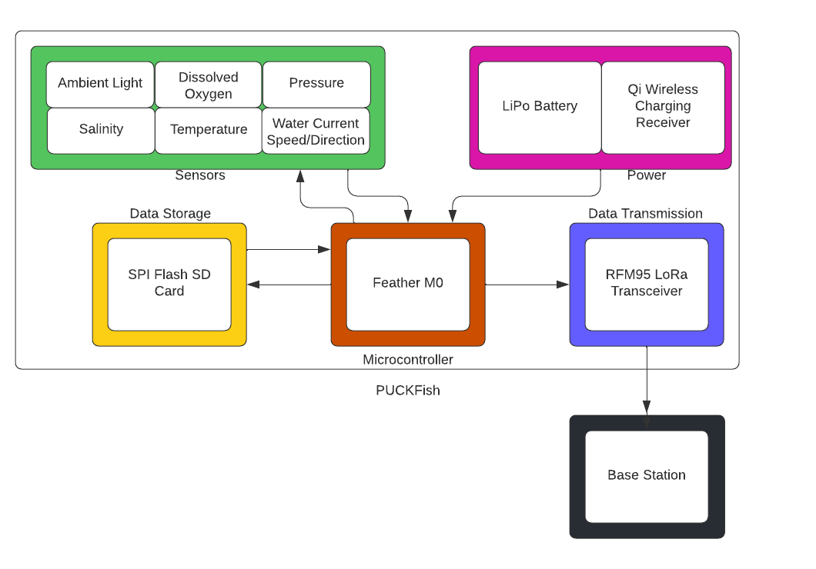

## Physical description.

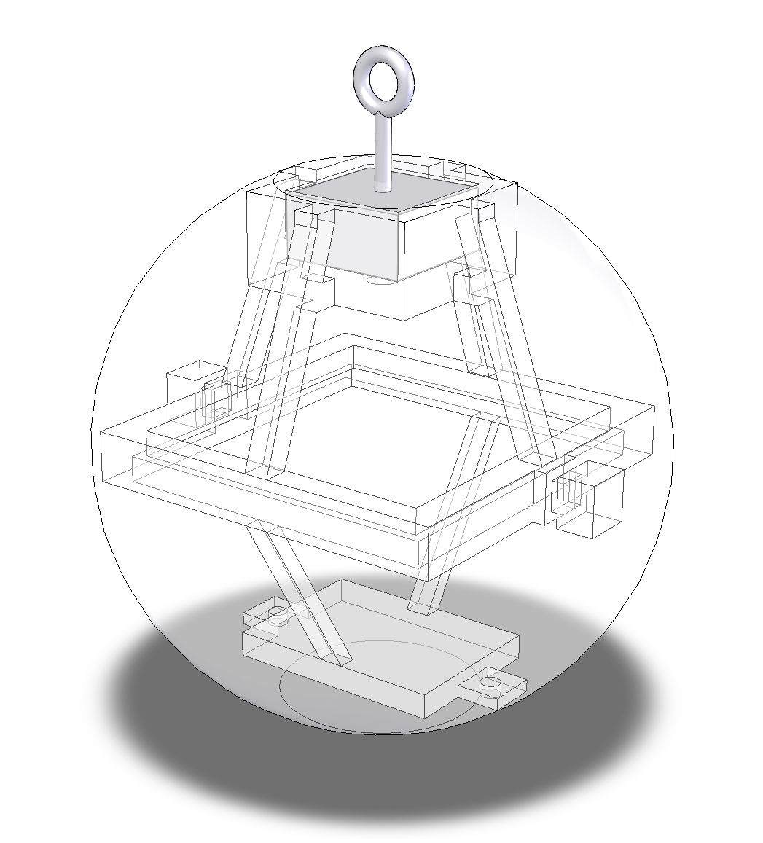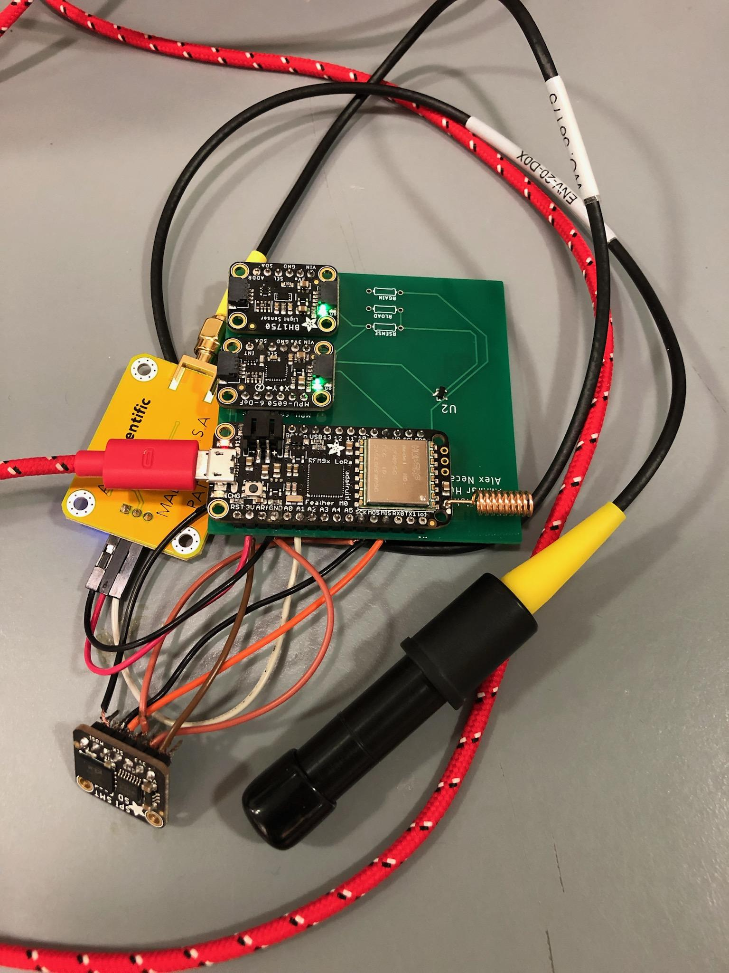

Figure 2: Skeleton and Mold Model Figure 3: PCB with Sensors

## Installation, setup, and support

Each PUCKFish device comes pre-built with no assembly required. The device needs to be charged using a Qi wireless charging pad. The device must be attached to a lobster trap line with the eye-bolt with enough slack for it to drift about underwater. The PUCKFish should be fully charged before use and the exterior sensor ports must not be obstructed to ensure full data collection and recovery. Software will automatically run on the PUCKFish while it is powered on. Receiving data from the PUCKFish will require users to run Fathom Fishing’s base station software.

For the dissolved oxygen sensor, the galvanic probe requires periodic recalibration with an electrolyte solution. Over time, this solution will be depleted and will eventually need to be refilled. To refill the probe, enough of the probe needs to be exposed to allow for the cap to be removed to refill the solution. When filling the solution, the user must use a standard syringe to fill the cap to its brim with the solution. Once The solution is filled, the cap must be properly screwed back on to ensure no leakage and to prevent corrosion.

# PUCKFish Operating Modes

## Operating Mode 1: Normal Operation

In normal operating mode, users will collect and receive data from the PUCKFish as follows:

1. Charge PUCKFish with charging pad
2. Affix PUCKFish to trap line
3. Submerge PUCKFish underwater
4. Run Fathom Fishing base station software
5. Pull up trap with attached PUCKFish
6. Receive transmitted data on base station

PUCKFish devices will collect sensor data from the undersea environment once per hour during normal operation. Future models may have configurable polling frequency.

## Operating Mode 2: Abnormal Operations

Abnormal operations include exterior sensor ports being obstructed, the device running out of battery, or damage due to loss of shell integrity.

If sensor ports are obstructed, the PUCKFish will not be able to retrieve the full suite of data from the environment. Any blockage or corrosion should be cleared out before future use.

If the PUCKFish runs out of battery, the data it has collected will be kept in persistent storage. When recharged, the device will be able to transmit all previously collected data.

If shell integrity is compromised on a PUCKFish unit, the device should be discontinued from use as we can no longer guarantee water/pressure proofing. Continued use will further damage the device and potentially lead to a loss of the data stored on PUCKFish.

## Safety Issues

It is important to make sure the PUCKFish device is firmly affixed to the trap line during use. If the device comes loose from the line, it will most likely be unrecoverable and damage the lobster habitats.

Do not:

1. Load PUCKFish or use PUCKFish to tow or lift loads.
2. Attempt to access electronics inside PUCKFish’s epoxy enclosure.
3. Add additional loading points to PUCKFish. Use only the eye bolts provided.

# Technical Background

## 4.1 Introduction: Lobster Ecology and Environment

Lobsters are scavenging crustaceans which subsist off of decaying organic material at the bottom of certain ocean zones. They are typically found in northern cold-water environments. Although there are many species of lobster, the basics of ecology and environment are similar between them, especially in the North American territories where large populations of commercial interest exist. Although basic migration information is known about lobsters as they move closer or further away from shore depending on the season, little is known exactly on the best location to find any particular species during a migration period.

Despite uncertainties of specific locations, general locations are known of habitation on the ocean floor. It is generally understood that lobsters may live in ocean zones as deep as 1100 feet.

Because of the uncertainty of preferred habitation zones of lobsters, PUCKFish applies basic marine biology to inform the choice of sensors to find population densities for lobsters. An environment’s suitability for marine life depends on several major factors.

1. Temperature
   1. Different marine species prefer different temperatures in relation to their body temperature to function optimally. Temperature can affect basic biological processes such as metabolism, reproduction, and growth.
2. Depth
   1. Pressure differences affect the physiological structure of marine life. Fish or animals may be better suited to either higher or lower pressures depending on their role in the ecosystem.
3. Ambient Light
   1. Marine plant life depends upon photosynthesis to produce energy. As plant life or algae are commonly the base of the ecosystem, different light amounts may point to more dense populations of plant life, and thus, other forms of marine life.
4. Dissolved Oxygen
   1. Marine life extracts dissolved oxygen from water in order to maintain biological function. The amount of oxygen available in the water tends to increase proportionally with the availability of marine life
5. Current Speed and Direction
   1. Current speed and direction can show migration patterns as well as still spots where habitats can form without the force of the current moving them around.
6. Salinity
   1. Salinity affects marine life, as they typically have optimal ranges in which they prefer to reside. The biological effects of salt impact functions like osmosis and metabolic processes which are key processes that sustain life for aquatic life.

The ideal sensor cluster and housing to collect this data may be developed in order to provide a model with information from basic principles of marine biology and a general understanding of lobster habitats.

## 4.2 Sensors: Modus Operandi and Selection

This section covers the sensors that measure the factors that indicate higher population density of lobsters.

### 4.2.1 Temperature and Depth

PUCKFish uses a piezoresistor sensor which is ported directly to a 24 bit output to read temperature and pressure directly. Piezoresistor pressure sensors make use of the piezoresistor mass-spring-like effect in order to read back pressures. When the piezoelectric resistor is put under pressure and subjected to temperature, it produces a change in resistance, which is then read by the sensor as data to the board. The model used in PUCKFish is a TE Connectivity MS5837-30BA . Pressure can be used to find the depth. Water has a semi-consistent density and models of ocean depth exist to produce a conversion between the pressure read and the depth of the water.

### 4.2.2 Ambient Light

PUCKFish uses a photodetector to measure the ambient light in its environment. It uses a photodiode, which has a similar spectral response to the human eye. When light enters the photodiode, it generates an electric current which the sensor then identifies, digitizes, and converts to a measurement of Lux, the SI measurement for light. The model used by PUCKFish is a light sensor with a breakout board, the Adafruit BH1750 Light Sensor.

### 4.2.3 Dissolved Oxygen

PUCKFish uses an electro-galvanic oxygen sensor in order to measure the dissolved oxygen within the water. The probe contains a fuel when placed in water allowing a chemical reaction to occur with both the water and the oxygen. This reaction releases free electrons which then, with the galvanic probe, create a voltage that is measured and corresponds to the amount of dissolved oxygen in percent. The sensor then converts this percentage of oxygen to an analog signal which then can be read by the computer onboard PUCKFish. The model of sensor onboard PUCKFish is the Gravity™ Analog Dissolved Oxygen Meter.

### 4.2.4 Salinity

PUCKFish uses a current meter to measure the salinity of the water. Electrical conductance through water is proportional to the electrolytes. In sea water’s case this electrolyte is salt. The salinity of the water can be backed out through look-up table to determine the required amount of salinity found in the water. The current sensor used to determine the salinity is the DIODES ZXCT1107SA-7.

### 4.2.5 Current Speed and Direction

Because PUCKFish is buoyant, the whole device shifts on a line attached to the lobster trap. Because of this, the angle of the device relative to the gravity vector can be used to determine trends of current speed and direction. This angle is created by the current of the water which creates a hydrodynamic force on the device as it pushes past it. In order to measure the amount the PUCKFish is pushed to the side as well as the direction it is doing so, an IMU, or inertial measurement unit, is used. The IMU onboard PUCKFish is the MPU-6050 on a breakout board provided by Adafruit.

## 4.3: Enclosure and Protection Against the Elements

### 4.3.1: Waterproofing

Because PUCKFish must operate underwater, the electronics must be protected from water getting inside. To counter water intrusion, an internal skeleton holds electronic components in place while a marine epoxy forms a protective shell around the electronics. Any sensor that requires access to the exterior of the device has sealing provisions so water has no way of penetrating into the epoxy enclosure.

### 4.3.2: Pressure Resistance

PUCKFish is required to operate at a maximum depth of 1,100 feet below the water’s surface where it must withstand 34.4 atm of pressure, or 3 MPa. In order to avoid damage to the structure or electronics, the device must be made of a material that can not only withstand the pressure, but also resist compression. The device is made of marine epoxy. This marine epoxy is resistant to corrosion and has a compressive strength of 85.4 MPa. The epoxy will withstand the pressures expected and limit the compressive strain inside the device to reasonable levels.

### 4.3.3: Floatation

PUCKFish must float to measure current with the IMU. By implementing Archimedes' principle of buoyancy, it can be shown that the device has a specific density greater than that of water. An underwater float is introduced in order to provide floatation. The value of this float generates approximately double the force required to make the device float.

## 4.4: Data Transmission and Charging

### 4.4.1: Data Transmission

Because water blocks radio waves, the device must be retrieved to collect the data stored on the PCB. In order to transmit data, PUCKFish has an onboard LoRa radio to transmit to a base station. The data transmitted is formatted into a csv file that can then be read and fed to models of the user’s choosing.

### 4.4.2: Charging

Charging ports provide a possible entry point for salt water as well as an opportunity for charging leads to rapid corrosion because of their exposure to water. As a result, PUCKFish uses an inductor to charge wirelessly. A magnetic field is generated that excites a current to move in a receiving charger inside PUCKFish through the epoxy covering.

# Relevant Engineering Standards

PUCKFish must adhere to a set of various engineering standards in each of its respective components. From the electronics perspective, PUCKfish is an array of various sensors each with their own software driver to communicate with the microcontroller. The sensors all adhere to I2C specification. For the dissolved oxygen sensor, ambient light sensor, and the current measuring IMU, we had access to existing open source code provided by the respective manufacturers, Atlas Scientific and Adafruit respectively. For the pressure sensor, we had to write our own driver. Similarly, for the salinity sensor, we had to write a driver that would take the output of the current sensing diode and convert that to a salinity measurement through the following formula ([Sciencing](https://sciencing.com/convert-specific-gravity-weight-6018708.html)).

Salinity(*parts per liter)* = (conductivity(*milliSiemens/m*) ^1.0878)*0.4665

To transmit data, we are using the Standard for a Smart Transducer Interface for Sensors and Actuator -LoRa Protocol ([IEEE P1451.5](https://standards.ieee.org/ieee/1451.5.5/10611/)) from the PUCKFish device to the base station on the boat. This standard allows for high accuracy and secure, easy use. Before the PUCKFish transmits data taken during a measurement period, it needs to store that data on-board until it is lifted out of the water. To store the data, we are using a SPI Flash SD Card breakout board, which adheres to SD card standards ([SD Association](https://www.sdcard.org/developers/sd-standard-overview/)) and is compatible with standard SD card libraries for the microcontroller. For storage format, we are using JSON formatting and the existing associated libraries for the microcontroller.

The main computer on PUCKFish adheres to the Association Connecting Electronics Industries ([IPC](https://www.ipc.org/ipc-standards)) standards along with the standards set by the PCB manufacturer, JLC, for both the design and manufacturing of the boards.

For charging the PUCKFish, we are using a Qi receiver and transmitter, which is the industry standard for inductive wireless charging. The receiver will be on the device itself, while the transmitter will be on the base station on the boat.

The mold for the epoxy enclosure has a drafting angle of 5 degrees to ensure easy removal of the silicone component. It is standard to use a drafting angle between 1 and 5 degrees.

# Cost Breakdown

Currently, the biggest cost driver is the dissolved oxygen sensor. This cost is due to the sensitive nature of this device and the relatively niche market for it. Before going to market, we plan to find a correlation between the other data we collect and dissolved oxygen, as this discovery would drive down cost and complexity significantly. Unfortunately, dissolved oxygen is also one of the most crucial drivers of lobster habitation, and thus we cannot afford to scrap the dissolved oxygen sensor at this time.

| Project Costs for Production of Beta Version (Next Unit after Prototype) | | | | |
| --- | --- | --- | --- | --- |
| Item | Quantity | Description | Unit Cost | Extended Cost |
| Epoxy Resin and Hardener | 0.183 Gal | Two part epoxy mixture, of a 1.5 Gal kit | $172.78 | $21.08 |
| 3D Printed Skeleton | 1 | Skeleton mount for PCB, sensors, eyebolt mount | $10 | $10 |
| Eyebolt | 1 | Eyebolt for tying to trap | $1.50 | $1.50 |
| Aluminum Eyebolt Mount | 1 | Aluminum block for skeleton mount, drilled and threaded for eyebolt | $15 | $15 |
| PCB | 1 |  | $4.60 | $4.60 |
| Dissolved O2 Sensor | 1 |  | $152.99 | $152.99 |
| Light Sensor | 1 |  | $1.06 | $1.06 |
| IMU | 1 |  | $7.78 | $7.78 |
| Salinity Sensor | 1 |  | $0.90 | $0.90 |
| Temperature and Pressure Sensor | 1 |  | $30 | $30 |
| Beta Version-Total Cost | | | | $244.91 |

# Appendices

*[Appendices include supplemental information for the User that would distract if included in the regular sections.*

## Appendix A – Team Information

**Alex Necakov (CE 2022) -** [**alexrn@bu.edu**](mailto:alexrn@bu.edu) **(203)-822-3119**

Alex is an undergraduate pursuing a B.S. in computer engineering at Boston University. Although specializing in software engineering, Alex has gained experience in a breadth of ECE related fields including robotics and rocket electronics design. Working with embedded electronics has been his main focus in his undergraduate experience. Alex uses this experience with embedded electronics on the ECE side of PUCKFish.

**Victoria Thomas (ME 2022) -** [**vmthomas@bu.edu**](mailto:vmthomas@bu.edu) **(508)-431-3947**

Victoria is pursuing an undergraduate degree in mechanical engineering with an aerospace concentration from Easton, MA. Due to her significant hands-on manufacturing experience, Victoria applies manufacturing planning and processes to build PUCKFish. This semester she performed water testing on this device and helped to design and create the electronics bed. After graduation Victoria will be working in manufacturing at GE Aviation in Lynn, MA.

**Ammar Hussain (EE 2022) -** [**hussaina@bu.edu**](mailto:hussaina@bu.edu) **(617)-281-9858**

Ammar is an undergraduate pursuing a B.S. in electrical engineering at Boston University from Brookline, MA. Ammar has experience with microelectronic circuits, and has an interest in sensor development. Additionally, he has long had a passion for marine biology and hopes to combine interest with his technical background to PUCKFish.

**Will Aracri (ME 2022) -** [**waracri@bu.edu**](mailto:waracri@bu.edu) **(412)-952-8185**

Will is an engineering student from Pittsburgh ,PA. He spent a year and a half in industry before returning to Boston to complete his degree. He specializes in testing and manufacturing procedures.

**Peter Ha (ME 2022) -** [**peterha@bu.edu**](mailto:peterha@bu.edu) **857-321-1112**